Qualitative Choice and Logit Regression
------ A Utility Point of View

Notes prepared by: Yinqi Zhang
(What I did is just organizing and picking the core content from the following source.)
Notes Source:
Kenneth E. Train, Qualitative Choice Analysis: Theory, Econometrics, and an Application to Automobile Demand. published by MIT Press, 1986, Chapter 1 and 2 and lecture notes.
Very nice Econometrics Link:
http://www.economics.ltsn.ac.uk/teaching/economet.htm
http://elsa.berkeley.edu/eml/qca1_archive.html

What is qualitative choice?
In any choice situation, the person making the choice has two or more different items, courses of action, or, more generally, “alternatives” among which to choose.
The characteristics of the qualitative choice:
- the number of alternatives in the set is finite;
- the alternatives are mutually exclusive;
- the set of alternatives is exhaustive.

The properties of choice probabilities:
- Each of the choice has the probability necessarily between zero and one;
- The choice probabilities necessarily sum to one;
(3) Differences matter, but not absolute levels
The probability of choosing one alternative over the other is only affected by the relative utility of one alternative to the other, but not their absolute levels.

Utility point of view of qualitative choice models

1. What determines the probability in choosing an alternative?

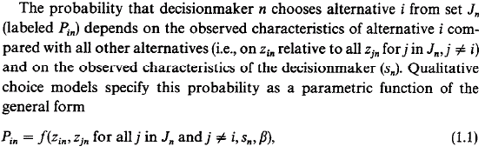
e.g. When a person chooses which automobile to buy, the observed characteristics of one brand of car (Zin) include price, fuel efficiency, seating capacity and so on; while the observed characteristics of the decision maker (Sn) include income, family size and so on.

2. Why utility is related here?
The decision maker chooses the alternative from which he derives the greatest utility.
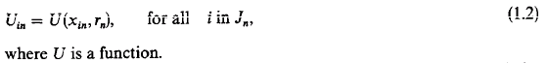
where Xin is the vector of all relevant characteristics of alternative i as faced by person n; rn is the vector of all relevant characteristics of person n.
The decision maker chooses alternative i in Jn if and only if


3. The link between utility and probability of choosing an alternative


Researcher does not know entirely, so he cannot perfectly predict the decision maker’s choice. However, the researcher knows part of the decision maker’s utility, , and with this information is able to make educated guesses as to the decision maker’s choice.

The choice probability defined on the researcher:
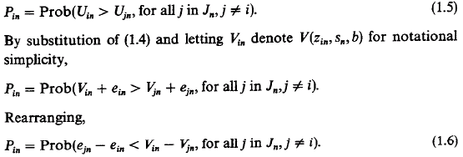
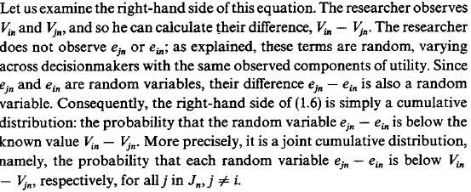
e.g. Consider the choice of the choice of way of transportation. If the observed utility for car Vc=4 and the observed utility for bus Vb=3,
$$P_{C}=\text{Pr}\text{ob}(e_{b}−e_{c}<V_{c}−V_{b})=\text{Pr}\text{ob}(e_{b}−e_{c}<1)$$
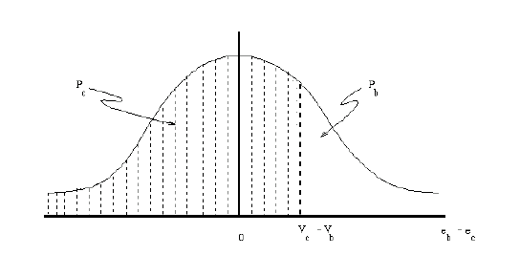

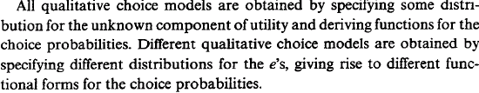

Logit Regressions
1. Function form
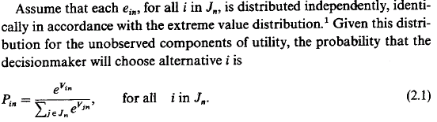

2. Some properties
(1) What logit model looks like?
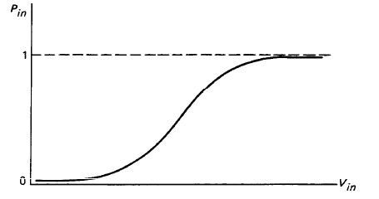

(2) The independence from irrelevant alternative property
Consider the ratio of the choice probabilities for two alternatives, i and k:
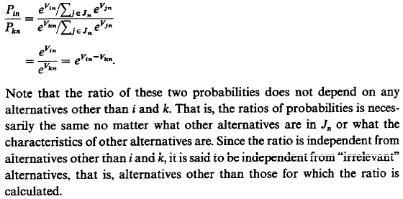
e.g. The decision of choosing Honda over Toyota is independent of the price of Volkswagon.

(3) Average probability is not equal to probability at the average of explanatory variables. Average impact of a change is not equal to the impact at the average of explanatory variables.
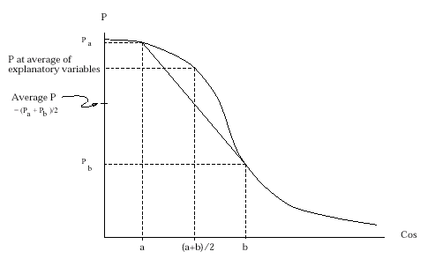
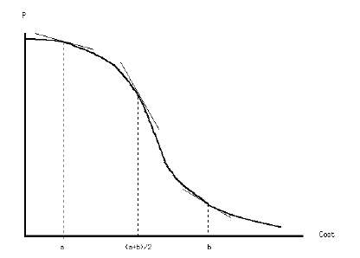

3. Taste Variation
The value, or importance, that decision makers place on each characteristic of alternative may vary over decision makers. This is called taste variation.
e.g. As discussed before, the size of a car is more important to bigger households than small households. Low income households are more concerned about the purchase price of a good, relative to other characteristics, than higher income households.

Logit models can capture taste variation, but only within limits. In particular, tastes that vary systematically with respect to observed variables can be incorporated in logit models, while tastes that vary with unobserved variables, or purely randomly, cannot be handled by logit model, but can be handled by probit model.

e.g. Again, consider when a person considers the choice of the brand of the car he wants to purchase. Suppose, for simplicity, that the only two characteristics of cars that the researcher observes is the purchase price (PPi) and the size of the car (SIZEi). The value that different people place on these two characteristics varies over people, so the total utility of person n on car i is:
$$U_{\text{in}}=α_{n}{\text{SIZE}}_{i}+β_{n}{\text{PP}}_{i}+e_{\text{in}}$$
The parameters vary over people reflecting differences in people’s tastes. Suppose, for example, that the value of car size varies with the number of members in ones household (Mn) but nothing else:
$$α_{n}={ρM}_{n}$$
so that as Mn increases, the value of size, $α_{n}$, also increases. Similarly, suppose the importance of purchase price is inversely related to income (In), so that low income people place larger importance to purchase price:
$$β_{n}=θ/{I_{n}}$$
Substituting these relations into the original model
$$U_{\text{in}}=ρ(M_{n}{\text{SIZE}}_{i})+θ({{\text{PP}}_{i}}/{I_{n}})+e_{\text{in}}$$

Other specifications for the variation in tastes can be substituted. For example, the value of size might be assumed to increase with the number of members in ones household, but at a decreasing rate, so that
$$α_{n}={ρM}_{n}+{φM}_{n^{2}}$$
where $ρ$ is expected to be positive and $φ$ negative. Then
$$U_{\text{in}}=ρ(M_{n}{\text{SIZE}}_{i})+φ(M_{n^{2}}{\text{SIZE}}_{i})θ({{\text{PP}}_{i}}/{I_{n}})+e_{\text{in}}$$

4. Marginal probabilities and elasticity of probabilities
(1) The change in the probability of choosing alternative i given a change in an observed factor yin.

(2) The change in the probability of choosing alternative i given a change in an observed factor yjn. yjn denotes an attribute of alternative j.

(3) The elasticity of the probability of choosing alternative i with respect of an observed factor yin.

5. Choice based sample estimation
For a choice based sample, the population is divided into those that choose each alternative and decision makers within each group are drawn randomly, though at different rates. The most widely used choice based sample is matched sample.
e.g. A researcher who is examining the choice of home location and is interested in identifying the factors that contribute to people choosing one particular community might draw randomly from within that community at the rate of one out of N households, and draw randomly from all other communities at a rate of one out of M, where M is larger than N.

If the researcher uses choice based sample and includes a constant in the logit model, then all the model parameters except the constant are consistent and unbiased. Furthermore, the constant is biased by a known factor and can be adjusted so that the adjusted constant is consistent and unbiased.
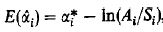
where is the estimated constant, is the true constant, Ai is the proportion of decision makers in the population that choose alternative i, Si is the proportion in the choice based
sample that choose alternative i.
Exercises
Given a logit regression and the following statistics, please calculate marginal effects of independent variable.
Note: marginal effect of each independent variable is calculated as its estimated coefficient times its interquartile range times the logit density function evaluated at the sample means of the independent variables.
Note: logit density function
$$\begin{aligned}f(t)={\left(\frac{e^{t}}{1+e^{t}}\right)}^{'}=\frac{e^{t}}{(1+e^{t})^{2}} \\ \text{where}:t=βx\end{aligned}$$

Review Report Indicator
Variablea | Mean | Coefficient  z-statictics | Interquatile  Change | Marginal  Effects
Intercept |  | -9.5804  -7.46***
New Financing | 0.5577 | -0.0658  -0.31 | 1 | ?
Management Ownership | 21.6213 | -0.0006  -0.11 | 27.8804 | ?
Debt/Assets | 0.1793 | 0.2978  0.60 | 0.2864 | ?
Size | 19.6941 | 0.4027  5.76*** | 2.8912 | ?
Segment Number | 1.9875 | 0.0530  0.95 | 2 | ?
Big Five | 0.8691 | -1.2976  -4.78*** | 0 | ?
Litigation Risk | 0.1715 | -1.6419  -1.93** | 0.1895 | ?
Pseudo-R2 |  | 0.0682
N |  | 1994

Answer:
Research Project
Voluntary disclosure of independent auditor’s review report in 10-Q filing

Motivation
- All SEC registered firms are timely reviewed after Mar 15, 2000, while few companies disclose auditors’ review report in their 10-Q filings. Why?
- What is auditor’s consideration in voluntary disclosure?

Background
To increase the reliability and timeliness of quarterly financial information, Final Rule: Audit Committee Disclosure (1999, Release no. 34-42266) makes timely quarterly reviews mandatory to all SEC registered firms, but there is no requirement in the Final Rule that firms attach the auditor’s review report in their 10-Q filings.
Note 1: When a review of interim financial reports by firm’s independent auditor is done before the filing of the reports, it is called timely review. When a review of interim financial reports is delayed until the end of the fiscal year, it is called retrospective review.
Note 2: Before the Final Rule, the Big 5 and some other accounting firms have already practiced timely review on their clients.
Pros for disclosure of review report:
Arthur Anderson:
We believe that requiring the report to be filed as an exhibit would benefit both auditors and investors. If the Commission requires an interim review, investors should understand the scope of the procedures involved in a review. Absent having access to the auditor's review report, investors might place more reliance on the review process than is appropriate based on the limitations of a review. The review report communicates the work that has been performed and the limited reliance that should be placed on the results of the review. In addition, without seeing the report, investors would not know whether the auditor qualified its report for any reason.
Cons for disclosure of review report:
Robert Elliott, Chairman of AICPA
As stated above, we believe the involvement of independent accountants with interim financial information improves the reliability of such information. The benefits of interim involvement, however, are derived from the actual reviews performed, not the issuance and filing of a review report. We believe, therefore that the Commission should not require that a report resulting from the independent auditors' review be filed.
Black & Decker Corp
The issuance of a review report could be misleading to the investing community, as the reduced nature and scope of such reviews may be unclear.

Previous Literature
1. Timely review
- Ettredge et al. (2000) document that timely-reviewed firms have less deferral adjustments in the fourth quarter than firms which are retrospectively reviewed.
- Manry et al. (2003) finds that timely-reviewed interim earnings are more closely associated with contemporaneous stock returns than retrospectively-reviewed earnings.
2. Voluntary disclosure
Previous literature links motives for voluntary disclosure to capital market transactions, agency costs, management compensation, litigation costs and proprietary costs. (Review of voluntary disclosure by Healy and Palepu 2001)
- Healy and Palepu (1993, 1995) hypothesize that investors’ perceptions are important to firms that anticipate capital market transactions. Verrecchia (2001) indicates that information asymmetry is one important component of cost of capital.
- Ettredge et al. (1994) find that companies with high internal and external agency costs are more likely to purchase timely quarterly review, although both timely review and retroactively review are allowed for their data period.
- Prior research in auditor resignation (Krishnan and Krishnan 1997, Shu 2000), auditor fee (Simunic 1980) and auditor opinion (Dopuch et al. 1987, Krishnan and Krishnan 1996) all identify that litigation risk is the major concern in auditor’s decision making.
- Kothari et al. 1988, Alexander 1991 show that sometimes investors view independent auditors as having “deep pocket”, which puts auditors into non-meritorious litigation.

Hypotheses Development
The decision of attachment of review report is a joint decision of the firm and its auditor. If we assume that the review report is the product a firm purchases from its auditor, then whether a review report is attached in 10-Q is determined both by the demand of the firm and by the auditor’s willingness to supply the review report.
Disclosure of review report is different from performing timely review. If investors are already informed that quarterly reviews are timely reviewed, disclosure of review report can be viewed as redundant.
Hypothesis 1: Ceteris paribus, firms that anticipate capital market transactions are as likely to attach independent auditor’s review report in their 10-Q filings as firms that do not anticipate capital market transactions.
Hypothesis 2: Ceteris paribus, Firms that have high agency costs are as likely to attach independent auditor’s review report as firms that have low agency costs in their 10-Q filings.
Hypothesis 3: Ceteris paribus, Firms with high litigation risk are less likely to attach independent auditor’s review report in their 10-Q filings.
Hypothesis 4: Ceteris paribus, Big-5 clients are as likely to attach independent auditor’s review report in their 10-Q filings as non-big 5 clients.

Model Specification
Review Report Indicator
where:
Review Report Indicator | = 1 for firms that attach review report in their 10-Q filings, 0 otherwise;
New Financing | = 1 for firms which has new financing ratio larger than 0.001. The new financing ratio is equal to the proceeds of new debt or equity issued during the current quarter or the following quarter deflated by total assets of the current quarter (COMPUSTAT QUARTERLY DATA14，61, 98, 86, 44);
Management Ownership | = percentage of common stock owned by officers and directors (DISCLOSURE);
Debt/Assets | = long term debt divided by total assets at the end of the quarter (COMPUSTAT QUARTERLY DATA44, 51);
Size | = natural log of total assets at the end of the quarter (COMPUSTAT QUARTERLY DATA44);
Segment Number | = the number of reported segments (COMPUSTAT SEGMENT DATA);
Big Five | = 1 if the auditor for the current year is Big Five accounting firm, 0 otherwise. (COMUPSTAT ANNUALY DATA149);
Litigation Risk | = the summary measure of litigation probability by Susan Shu (2002).

Table 1
Sample Selection

Firms which have data available on COMPUSTAT quarterly (both FCQ and INQ) 6461
Delete firms which are listed both in INQ and FCA 71
6390
Delete firms not traded on the New York or American Stock Exchanges
(firms with tickers like ****B or 3****) 1578
4812
Delete firms whose first quarter 10-Q is not available on Lexis-Nexis or SEC 1126
3686
Delete firms with management ownership missing from Disclosure 864
2822
Delete firms with auditor for the year 2000 missing from Disclosure 92
2730
Delete firms without sufficient data for calculating new financing from COMPUSTAT 279
2451
Delete firms without sufficient data for calculating Debt/Assets from COMPUSTAT 6
2445
Delete firms without sufficient data for calculating litigation risk 451
1994

Table 2
Descriptive Statistics

Panel A: Full sample(1994 observations)

 | Mean | Median | Std. Dev. | Min | Max
Review Report Indicator | 0.0627 | 0 | 0.2425 | 0 | 1
New Financing | 0.5577 | 1 |  | 0 | 1
Management Ownership | 21.6213 | 14.629 | 21.0318 | 0 | 97.3775
Debt/Assets | 0.1793 | 0.1053 | 0.21271 | 0 | 2.8781
Size | 19.6941 | 19.5644 | 2.1166 | 14.7477 | 27.2096
Segment Number | 1.9875 | 1 | 1.5263 | 1 | 11
Big Five | 0.8691 | 1 | 0.3374 | 0 | 1
Litigation Risk | 0.1715 | 0.1250 | 0.1566 | 0 | 1

Panel B: Comparison of mean and median of independent variables between 125 firms which issued review report and 1869 firms which did not issue report

 | Mean  t-statistics |  | Median  Wilcoxon Z
Review Report Indicator | 1 | 0 | 1 | 0
New Financing | 0.5680  0.2398 | 0.5570 | 1 | 1
Management Ownership | 17.3306  -2.4812*** | 21.9082 | 8.3664  -3.150*** | 14.9610
Debt/Assets | 0.2029  1.2754 | 0.1777 | 0.1343  1.689* | 0.1046
Size | 20.8682  5.7745*** | 19.6155 | 20.8566  5.965*** | 19.4897
Segment Number | 2.3040  2.0071** | 1.9663 | 1 | 1
Big Five | 0.8000  -2.0783** | 0.8737 | 1 | 1
Litigation Risk | 0.2130  2.8840*** | 0.1687 | 0.1713  3.471*** | 0.1229

* Significantly different from zero (two-tailed) at or below the 0.1 level.
** Significantly different from zero (two-tailed) at or below the 0.05 level.
*** Significantly different from zero (two-tailed) at or below the 0.01 level.

Table 3
Logit Regressions of Indicator for Review Report on
a Summary Measure of Litigation Risk and Other Explanatory Variables

Review Report Indicator
(1)

Variablea | Expected  Sign | Coefficient  z-statictics | Interquatile  Changeb | Marginal  Effectsc
Intercept |  | -9.5804  -7.46***
New Financing | ? | -0.0658  -0.31 | 1 | -0.0078
Management Ownership | ? | -0.0006  -0.11 | 27.8804 | -0.0020
Debt/Assets | ? | 0.2978  0.60 | 0.2864 | 0.0102
Size | + | 0.4027  5.76*** | 2.8912 | 0.1395
Segment Number | ? | 0.0530  0.95 | 2 | 0.0127
Big Five | ? | -1.2976  -4.78*** | 0
Litigation Risk | - | -1.6419  -1.93** | 0.1895 | -0.0373
Pseudo-R2 |  | 0.0682
N |  | 1994

* Significantly different from zero (two-tailed) at or below the 0.1 level.
** Significantly different from zero (two-tailed) at or below the 0.05 level.
*** Significantly different from zero (two-tailed) at or below the 0.01 level.
a All variables are defined in Table 2.
b The interquartile range (i.e., from the 25th percentile to the 75th percentile).
c The marginal effect represents the change in the probability of attachment of review report given a change in the independent variable over the interquartile range.

Table 4
Multivariate logit regressions

Variablea | Expected  Sign | Coefficient  z-statictics | Interquatile  Changeb | Marginal  Effectsc
Intercept |  | -8.0436  -6.75***
New Financing | ? | -0.1014  -0.45 | 1 | -0.0043
Management Ownership | ? | 0.0006  0.11 | 27.8804 | 0.0007
Debt/Assets | ? | -0.6919  -1.10 | 0.2864 | -0.0084
Size | + | 0.3381  5.36*** | 2.8912 | 0.0415
Segment Number | ? | 0.0107  0.19 | 2 | 0.0009
Big Five | ? | -1.4709  -5.10*** | 0
Inventory/Assets | - | 0.1830  0.24 | 0.1406 | 0.0011
Receivables/Assets | - | -2.3755  -3.89*** | 0.2384 | -0.0241
Return on Assets | + | 0.3346  0.95 | 0.0907 | 0.0013
Financial Leverage | - | 0.8455  1.42 | 0.4724 | 0.0170
Sales Growth | - | -0.0279  -0.35 | 0.3436 | -0.0004
Stock Return | + | 0.0917  1.45 | 0.9692 | 0.0038
Beta | - | -0.4103  -2.47*** | 1.0625 | -0.0185
Turnover | - | 0.3746  0.78 | 0.4764 | 0.0076
Delist Dummy | - | -0.1005  -0.10 | 0
Technology Dummy | - | 0.1388  0.39 | 0
Pseudo-R2 |  | 0.0913
N |  | 1994

* Significantly different from zero (two-tailed) at or below the 0.1 level.
** Significantly different from zero (two-tailed) at or below the 0.05 level.
*** Significantly different from zero (two-tailed) at or below the 0.01 level.
a b c Defined same as in Table 3.

